Calvin’s Institutes of Christian Religion
Recap//Summary of Books I-II
- Lesson 1: Introduction & Preface
  - Title: Institutions of the Christian Religion Prefatory Address TO HIS MOST CHRISTIAN MAJESTY, THE MOST MIGHTY AND ILLUSTRIOUS MONARCH, Francis, King of the French, HIS SOVEREIGN; JOHN CALVIN PRAYS PEACE AND SALVATION IN CHRIST.
  - Purpose of the Book: “…to transmit certain rudiments by which those who are touched with any zeal for religion might be shaped to true godliness. And I undertook this labor especially for our French countrymen, very many of whom I knew to be hungering and thirsting for Christ; but I saw very few who had been duly imbued with even a slight knowledge of him.”
  - Secondary purpose: To vindicate the Protestant faith as true religion and not heresy
  - The Ending: “Most illustrious King, may the Lord, the King of kings, establish your throne in righteousness, and your sceptre in equity. Basle, 23rd August 1535.”
- Book 1 focuses on knowledge of God as Creator
- Lesson 2: Knowledge of God the Creator (1.1-5)
  - Without knowledge of self, there is no knowledge of God
  - Without knowledge of God, there is no knowledge of self
  - Definition: The knowledge of God in practice is reverence
  - God has implanted in all mankind a knowledge of Himself. This knowledge is suppressed by ignorance and leads unbelievers into superstition. But this blindness does not render one without excuse because this blindness comes from pride and stubbornness.
  - Not only has God implanted knowledge of Himself in our minds, but also in His creation.
  - God is clearly manifested in all of His works of creation and providence [good and bad] and the way to find God is not to meditate on His essence but to contemplate His works.
  - This knowledge of God ought to awaken us to worship God and arouse us to the hope of future life.
  - And yet we fail in using this proper knowledge rightly.
  - Because we distort the manifest revelation of God, we are all without excuse.
  - We cannot arrive at true knowledge of God from nature alone because we suppress it.
- Lesson 3: The Necessity of Scripture (1.6-9)
  - Because we distort God’s general revelation of Himself, another superior help is needed to direct us to God and that superior revelation is Scripture.
  - Scripture is God’s power unto salvation (Rom. 10)
  - Scripture is necessary to help us distinguish between the true God who created and all false gods invented in man’s imagination
  - The authority of Scripture comes not from men but from the Spirit of God. The conviction that Scripture is God’s Word comes not from ourselves but also from the Spirit.
  - The Spirit without the Word is dangerous;
The Word without the Spirit is deadly;
The Word with the Spirit is dynamite.
- Lesson 4: The True God, Pt. I (1.10-12)
  - As God’s Word, Scripture gives us a fuller and clearer revelation than God’s revelation in creation, though both are in agreement. Scripture is more intimate and more vivid than general revelation.
  - Images displease God because they dishonor His majesty.
  - God has used signs to reveal Himself but even in these signs, He remains hidden.
  - The so-called “worship” of Catholic saints detracts from God’s glory as outright idolatry. The distinction between dulia [service] and latria [worship] is not sufficient because in Scripture, we serve what/who we worship.
  - Regulative Principle of Worship: “He has been pleased to prescribe in his Law what is lawful and right, and thus astrict men to a certain rule, lest any should allow themselves to devise a worship of their own.”
- Lesson 5: The True God, Pt. II: The Trinity (1.13)
  - There is one God.
  - There are 3 persons within the one Godhead: Father, Son, and Holy Spirit
  - The 3 persons are distinct, yet are not divided or separated.
  - The Father is not the Son; The Son is not the Spirit; the Spirit is not the Father.
  - The Father is God; The Son is God; The Spirit is God.
- Lesson 6: Creation of All Things (1.14-15)
  - Creation calls us to faith in God.
  - Creation is God’s “most beautiful theater” and we should “piously delight” in it
  - Creation was created “out of nothing” and is upheld by God’s word.
  - God displays His glorious perfections in Creation.
  - God created all things for our good and salvation.
  - Our reaction should be greater trust, praise, and love for God.
  - Man is God’s noblest and most remarkable work of creation. Man was made in God’s image in a state of integrity (or innocence) but he sinned against God and fell from that state of integrity.
- Lesson 7: Providence (1.16-18)
  - God is not an aloof monarch once He finished creating. God governs, sustains, and nourishes His creation by His providence.
  - There is no such thing as “chance”, “fate”, or “fortune”
  - One benefit of God’s providence is to teach us patience. Other benefits include to correct our wicked desires, aid us in practicing self-denial, and awaken us out of idleness.
  - We are not to rail against God’s providence, but to humbly submit ourselves to God’s plan in reverence and Godly fear.
  - God is sovereign even over sin and wickedness and can use evil acts in a sinful manner without overriding the choices of human beings.
- Book 2 focuses on knowledge of God as Redeemer, first in the OT then in the NT
- Lesson 8: The Fall & Human Corruption, Part 1 (2.1)
  - All humans descending from Adam (except Jesus) inherit original sin (guilt, corruption) from Adam.
  - No part of us is exempt from sin. The whole human nature is affected by original sin. This is what “Total Depravity” means. It’s not that we’re as bad as we possibly can be. It’s that no part of our nature is exempt from the corruption of original sin.
- Lesson 9: The Fall & Human Corruption, Part 2 (2.2-3)
  - Freedom from necessity [compulsion]: We are free as human beings. We are not robots or puppets. We are not compelled or forced in the actions that we choose.
  - Freedom from sin: This was lost in the Fall.
  - Freedom from misery: This was lost in the Fall.
  - “Man does not have free choice equally of good and evil; rather, it only means that he acts wickedly by will, not by compulsion.”
  - “Since Scripture proclaims throughout that it is the free gift of God, it follows, that when men, who are with their whole soul naturally prone to evil, begin to have a good will, it is owing to mere grace. Therefore, when the Lord, in the conversion of his people, sets down these two things as requisite to be done, viz., to take away the heart of stone, and give a heart of flesh, he openly declares, that, in order to our conversion to righteousness, what is ours must be taken away, and that what is substituted in its place is of himself.”
- Lesson 10: The Fall & Human Corruption, Part 3 (2.4-5)
  - When God bends the will of people, even unregenerate people, He is not to be blamed for their sins.
  - Job 1:17 – “While he [Job’s servant] was yet speaking, there came another and said, ‘The Chaldeans formed three groups and made a raid on the camels and took them and struck down the servants with the edge of the sword, and I alone have escaped to tell you.’”
    - What was Satan’s purpose in this attack?
      - Make Job curse God. This is evil intent.
    - What was God’s purpose in this attack?
      - Test Job’s faith. This is good intent.
    - What was the Chaldeans purpose in this attack?
      - Steal some camels and kill some people. This is evil intent.
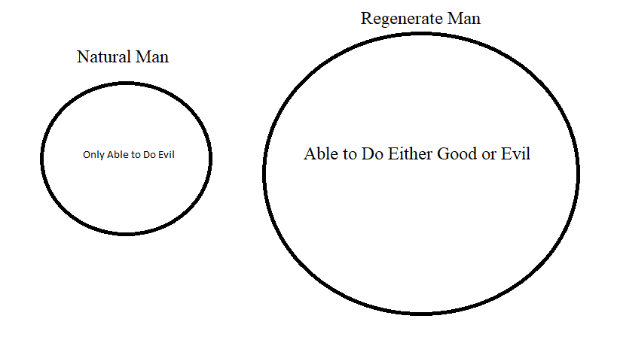
- Lesson 11: The Role of the Law as Part of God’s Work of Salvation, Part 1 (2.6-7)
  - The way of salvation has always been in Christ, both in the Old Testament and in the New Testament.
- The Three Uses of the Moral Law
  - Schoolmaster to lead us to Christ [Mirror]
  - Restrain Evil [Bridle]
  - Guide for Christian Living [Whip]
- Lesson 12: The Role of the Law as Part of God’s Work of Salvation, Part 2 (2.8)
  - Natural Law (conscience) = Moral Law
  - Three Things About the Moral Law Which Helps Us Discern What Each Commandment Requires and How It Functions
    - The law is Spiritual
    - Each Commandment has a wider scope of meaning and application than what is explicitly stated in the commandment
    - The Ten Commandments are divided into 2 tables
- Lesson 13: Christ the Redeemer – Promise & Fulfillment (2.9-11)
  - The Jews through the Law were kept in pious expectation of the coming Messiah. But the Messiah is more clearly revealed in the New Testament, especially the Gospels.
  - The Old Testament speaks in shadows and types and symbols, but now in the Gospels and New Testament we have the fulfillment. We have the reality.
  - Points of Similarity Between the OT and NT
    - Belief in Immortality
    - God’s free mercy & Christ the Mediator is present in both
    - The OT & NT sacraments are essentially the same
  - Points of Dissimilarity Between the OT and NT
    - In the OT, our heavenly heritage is displayed under earthly benefits; not so in the New Testament.
    - The OT shows an image where the New Testament reveals the substance.
    - The New Covenant is spiritual, the Old Covenant is literal.
Old Covenant [Mosaic] | New Covenant
Law | Gospel
Literal | Spiritual
Tablets of stone | Human hearts
Preaching of death | Preaching of life
Condemnation | righteousness
Voided | Abiding

    - The Old Covenant [Mosaic] enslaves while the New Covenant liberates.
    - One nation vs. All people
  - The substance/material of the covenants is the same, they only differ in how that substance is administered/conveyed.
- Lesson 14: The Person of Christ (2.12-14)
  - Christ had to become man in order to redeem man from sin. Christ took on real/true human flesh.
  - “The Son of God becomes the Son of Man, but not by confusion of substance but by unity of person. We affirm Christ’s divinity so joined and united with His humanity that each retains its distinctive nature unimpaired, and yet these two natures constitute one Christ.”
  - Hypostatic union – the union of the 2 natures in the 1 person, the Son of God
- Lesson 15: The Work of Christ, Part 1 (2.15-16a)
  - Christ fulfills the OT offices of Prophet, Priest, and King. As Prophet, He reveals God’s word and indeed IS God’s Word. As Priest, He offers us Himself as our Sacrifice and He intercedes for us. As King, He rules and reigns over all things.
  - Christ suffered under Pontius Pilate in order for the judicial verdict of guilty to be pronounced upon one who was innocent
- Lesson 16: The Work of Christ, Part 2 (2.16b-17)
  - Christ’s Redemption for us includes all that He endured on our behalf: crucifixion, death, burial, descent into hell, resurrection, ascension, reign at God’s right hand, return in judgment.
  - All of these are necessary components of our redemption in Christ.

