Revelation
Lesson 13 – Revelation 4:1-6a
- When we are tempted to speak and act as if the control of events and the destiny of the world rested in the hands of men instead of God, Chapter 4 ushers us into the throne room of God to behold the world from an eternal perspective in which God reigns in all matters, large and small, with absolute authority.
- “The occupied throne is the focus of this second cycle of visions. Seventeen times in Revelation 4 and 5, John speaks about this throne. All other symbols, such as colors, numbers, and pictures, should be understood in relation to this throne”. –Joel Beeke
 | Daniel | Revelation
Vision Introduction | 7:9 | 4:1
A throne in heaven | 7:9a | 4:2a
God sitting on a throne | 7:9b | 4:2b
God’s appearance on the throne | 7:9c | 4:3a
Fire before the throne | 7:9d-10a | 4:5
Heavenly servants surrounding the throne | 7:10b | 4:4b, 6b-10
Verse 1
- “After these things I saw and behold” should sound familiar to those of you who have been with us on Wednesday evenings.
- Zechariah 1:8 – “I saw in the night, and behold,….”
- John sees an open door in heaven and he hears an invitation to come up into heaven from a voice.
- This voice is described as “the first voice which I had heard speaking to me like a trumpet”
- Revelation 1:10, 12-13 – “I was in the Spirit on the Lord’s day, and I heard behind me a loud voice like a trumpet; ¹² Then I turned to see the voice that was speaking to me, and on turning I saw seven golden lampstands, ¹³ and in the midst of the lampstands one like a son of man,”
- “What must take place after this” refers to the rest of Revelation; that is, Revelation 4:1-22:5
- Daniel 2:28 – “there is a God in heaven who reveals mysteries, and he has made known to King Nebuchadnezzar what will be in the latter days” cf. Daniel 2:45 – “A great God has made known to the king what shall be after this”
Verses 2-3
- Verse 2 - John is transported/ascends into heaven through the Spirit and he sees a throne and somebody sitting on the throne.
- “In his prophetic role John is to go back and communicate God’s hidden purpose to His people and tell them what part they are to have in carrying it out.” –Greg Beale
- The throne is a symbol of sovereignty and it is at the center of John’s vision showing that God is the sovereign king over all of the universe.
- Verse 3 – the someone sitting on the throne is described as looking like jasper and carnelian [σάρδιον sardion] and around the throne is a rainbow that appears like emerald
- Jasper is a white or translucent stone like crystal. Some suppose it to be a diamond.
- Revelation 21:10-11 – “showed me the holy city Jerusalem coming down out of heaven from God, ¹¹ having the glory of God, its radiance like a most rare jewel, like a jasper, clear as crystal.”
- Exodus 28:17-19 – “You shall set in it four rows of stones. A row of sardius, topaz, and carbuncle shall be the first row; ¹⁸ and the second row an emerald, a sapphire, and a diamond; ¹⁹ and the third row a jacinth, an agate, and an amethyst; ²⁰ and the fourth row a beryl, an onyx, and a jasper.”
- Ezekiel 1:26, 28 – “²⁶ And above the expanse over their heads there was the likeness of a throne, in appearance like sapphire; and seated above the likeness of a throne was a likeness with a human appearance. ²⁸ Like the appearance of the bow that is in the cloud on the day of rain, so was the appearance of the brightness all around.”
- God’s appearance is truly indescribable so the best one can do whether seeing the heavenly throne room in the OT or in the NT is to liken it unto beautiful and brilliant gemstones. “God is Himself the ultimate source of splendor and beauty. His splendor is partly reflected in the things that He has made: the brightness and colors of the sun, of heavenly bodies, of the rainbow, and of precious jewels.” –Vern Poythress
- Why the rainbow? As He pours forth judgment upon the Earth, it is God’s eternal reminder of His promise not to destroy it again with a flood. Greg Beale says God’s judgment will be tempered with mercy.
Verse 4
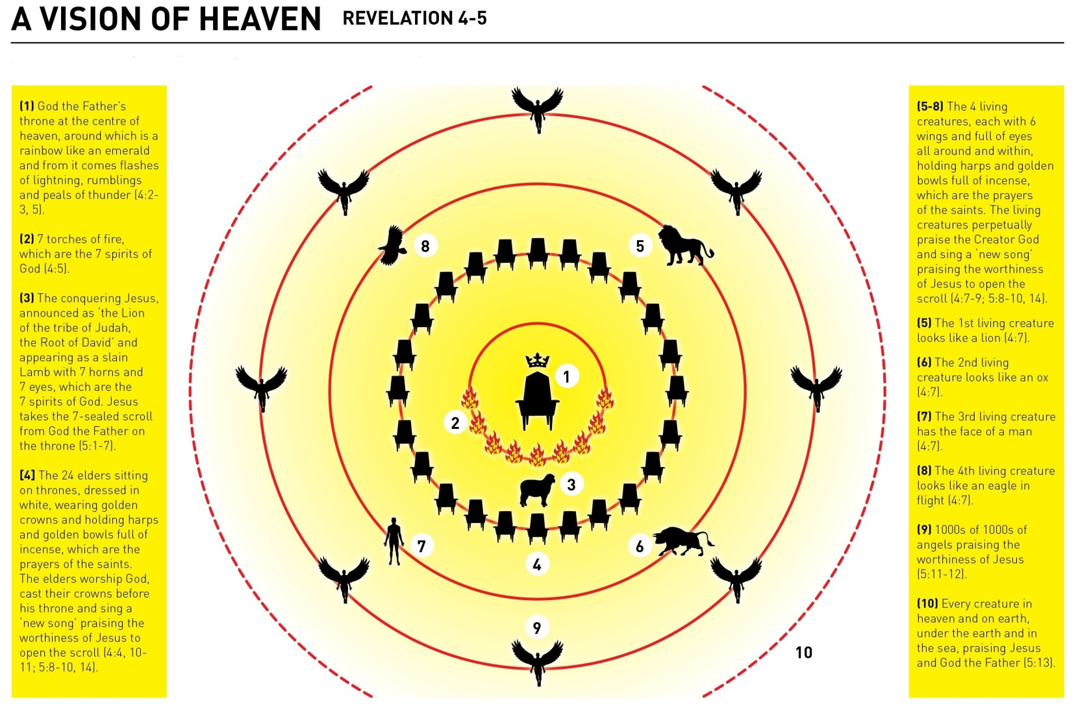
- Who are these elders?
  - Angels [Vern Poythress]
  - The whole Church, both OT & NT [William Hendricksen]
  - Angels who represent the whole Church, both OT & NT [Greg Beale]
- These beings are described as elders indicating that God is surrounded by wise counselors as His court attendants. They have thrones indicating a subordinate authority, white robes representing purity, and crowns of gold representing victory won. Since God’s people in Revelation are described similar is being given white robes, authority to rule with Christ, and crowns, it seems that these beings do reflect or image in heaven the whole Church on earth.
Verses 5-6a
- Verse 5 harkens us back to Mount Sinai where there were thunders and lightnings but this same phrase of “lighting, rumbling, and peals of thunder” occurs in Revelation 8:5, 11:19, and 16:18 at the end of 7 judgments so this represents God as the source of judgments that He is going to pour out from His heavenly throne room onto the Earth.
- Before the throne is 7 torches of fire which John tells us are the 7 spirits of God.
- Zechariah 4:2, 6 – “I see, and behold, a lampstand all of gold, with a bowl on the top of it, and seven lamps on it, with seven lips on each of the lamps that are on the top of it. ⁶ Then he said to me, “This is the word of the Lord to Zerubbabel: Not by might, nor by power, but by my Spirit, says the Lord of hosts.”
- The light of the Holy Spirit is the original light of which the 7-fold lampstand in Exodus 25:31-40 is a copy. 7 is the number of perfection and since the churches are represented in Revelation 1 as a 7-fold lampstand to which Jesus stands in the midst tending, the true Church which is the Temple of God, burns brightly reflecting the very presence of God through His Spirit.
- What is this sea of glass?
- Exodus 24:10 – “and they saw the God of Israel. There was under his feet as it were a pavement of sapphire stone, like the very heaven for clearness” Here the sea of glass is something under the Lord’s feet on which He walks.
- Revelation 15:2 – “And I saw what appeared to be a sea of glass mingled with fire—and also those who had conquered the beast and its image and the number of its name, standing beside the sea of glass with harps of God in their hands.” Here the sea of glass is an image of judgment over God’s enemies recalling God’s defeat of Pharaoh at the Red Sea.
- Ezekiel 1:22 – “Over the heads of the living creatures there was the likeness of an expanse, shining like awe-inspiring crystal, spread out above their heads.”
- This sea of glass is God sovereignly keeping under His feet all of His enemies that He has conquered in judgment. In Revelation 21:1, there is no longer any sea and instead there is a river of life.
Message for Us
- “John says in Revelation 4 that at the center of all the universe there sits a throne. The universe is not earth-centered or sun-centered, but God-centered.” –Joel Beeke
- “When God’s people are beset by temptation or persecution, a revelation of God’s character and glory is the best remedy. His power guarantees the final victory, His justice guarantees vindication of the right, and His goodness and magnificence guarantee blessing and comfort.” –Vern Poythress
- A vision of God’s glory, majesty, splendor, holiness, and judgment should produce in us greater fear of the Lord as the One with whom we have to deal. It should produce in us greater comfort as nothing can compare or touch our Sovereign King of the Universe. Therefore we can submit to His will and not fear what unbelievers may do to us or what may befall us in this world full of evil.
- “Life is not purposeless or meaningless. Nothing comes to us by mere chance. The One who is seated on the throne of heaven has His hand in everything that happens, from great international events to the minute matters of your spiritual world, your emotional world, your domestic and interpersonal world, your work world, and your physical world. Nothing that happens to you or in the world around you is purposeless or meaningless. God is on His throne.” –Joel Beeke

