Revelation
Lesson 5 – Revelation 1:9-20

John’s Commission (1:9-11)
- John doesn’t identify himself as an apostle but rather he calls himself a “brother” and “partner in the tribulation.” John is emphasizing his solidarity with the readers of his book.
- “John represents what all Christians can expect to go through.” –Vern Poythress
- We’re not told the historical details but John says in verse 9 that he exiled to the island of Patmos on account of the word of God and the testimony of Jesus. John was persecuted and punished for His loyalty to Jesus and the Gospel.
- John says 3 things are “in Jesus” tribulation, kingdom, and patient endurance. Here John says if you are in Jesus, you can expect suffering and John is experiencing it even as he writes this book.
- But, if you are in Jesus, there’s a flip side to suffering: Kingdom.
- Ephesians 2:6 – “and [God] raised us up with him [Jesus] and seated us with him [Jesus] in the heavenly places in Christ Jesus”
- 2 Timothy 2:12 – “if we endure, we will also reign with him; if we deny him, he also will deny us;”
- “This is a formula for kingship: only as one faithfully endures tribulation is the means by which one reigns in the present with Jesus. Believers are not mere subjects in Christ’s kingdom. ‘Fellow partaker’ underscores the active involvement of saints not only in enduring tribulation, but also in reigning in the midst of tribulation.” --Greg Beale
- What John is saying here, in concert with the rest of Scripture, is that the Christian life is called to the cross first before he or she gets the crown. Or, “victory through suffering.” This is the wisdom of God which seems foolish to the world. But this is the way of Jesus who Himself suffered to the point of death, but through suffering gained a crown and victory over ALL of His enemies.
- This is why we need, what in verse 9, John calls “patient endurance” which is also in Jesus. We have to endure while we suffer and we have to endure while we wait for the crown at the 2nd Coming. But even this endurance can only come from Jesus. It’s not something we can work up within ourselves.
- John was worshipping on Sunday even when he couldn’t gather with other saints corporately.
- “The Sunday celebration anticipates the celebration of God’s final victory.” –Vern Poythress
- And these visions are given by the Spirit. The Spirit transports John into the heavenly throne room where John hears a loud voice like a trumpet and hears a command to write down what he sees.
- There were trumpets sounding when God visited Moses on Mt. Sinai to reveal the Law to him.
- “Whenever God had anything to impart to His people during the Old Testament, He gathered them by means of a trumpet-sound (Ex 19:16, 19; Lev 25:9; Josh 6:5; Isa 58:1).” –William Hendriksen
- This command to write also reflects the OT language when Yahweh charges His prophets to communicate to Israel the revelation they receive.
- Exodus 17:14 – “Then the Lord said to Moses, “Write this as a memorial in a book and recite it in the ears of Joshua,”
- Isaiah 30:8 – “And now, go, write it before them on a tablet and inscribe it in a book, that it may be for the time to come as a witness forever.”
- Jer 30:1-2 – “The word that came to Jeremiah from the Lord: ² “Thus says the Lord, the God of Israel: Write in a book all the words that I have spoken to you.”
Vision of Jesus Christ (1:12-20)
- In this section, Jesus is gloriously displayed as the heavenly priest, end-time ruler, and judge.
- First, John sees 7 golden lampstands in verse 12. These represent the Church.
- In Zechariah 4:2-6, Zechariah sees a very similar vision and it is interpreted to mean that the Spirit of God is present among His people to empower them to do the work God has called them to do.
- “So New Israel, the church, is to draw its power from the Spirit, the divine presence, before God’s throne in its drive to stand against the world’s resistance.” –Greg Beale
- And in the midst of the lampstands, verse 13, is one like a Son of Man – Jesus Christ. And verses 13-16 describe Jesus with a series of Old Testament pictures/language.
- 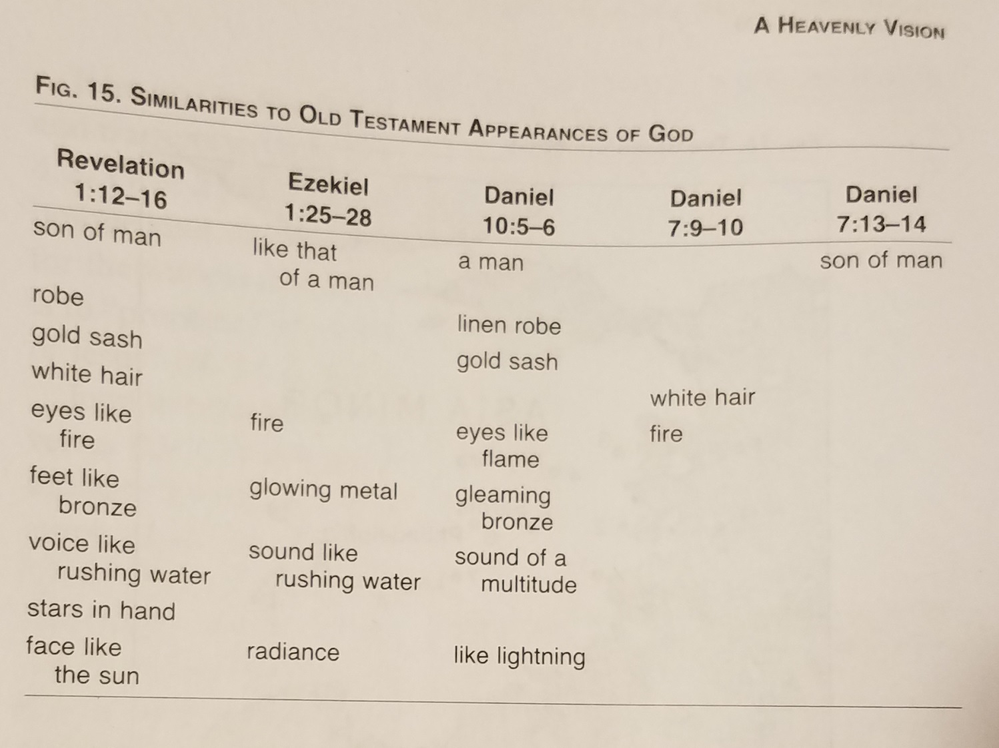
- Daniel 10:5-6 – “I lifted up my eyes and looked, and behold, a man clothed in linen, with a belt of fine gold from Uphaz around his waist. ⁶ His body was like beryl, his face like the appearance of lightning, his eyes like flaming torches, his arms and legs like the gleam of burnished bronze, and the sound of his words like the sound of a multitude.”
- “The entire picture, taken as a whole, is symbolical of Christ, the Holy One, coming to purge His churches, and to punish those who are persecuting His elect.” –William Hendriksen
- John’s reaction to this vision of Jesus Christ is similar to Daniel and also Isaiah in Isaiah 6.
- But Jesus comforts John by describing Himself with several titles, some of which we looked at last week.
- Jesus is the first and the last which includes everything in between. He is Sovereign over all things and Lord of history. Yahweh says the same thing in Isa 41:4, 44:6, 48:12. Jesus is identifying Himself as Yahweh which is further evidence of His divinity.
- Jesus is eternal in that He is the living one who is alive forevermore. Because of His death and resurrection, He now holds the keys of Death and Hades which means He rules even over them. Christ’s sovereignty extends to Death, the grave, and hell.
- So in verse 19, John receives his commission to write down and what he is to write down relates to the past (what you have seen), the present, (those that are), and the future (those that are to take place after this). Again this confirms our approach to Revelation that it is a book about the past, present, and future.
- And then in verse 20, Jesus interprets what John saw in the vision, specifically what the 7 stars are that Jesus is holding in His right hand (stars = “angels of the 7 churches”) and Jesus tells John the 7 lampstands are the 7 churches which again confirms our understanding of the symbolism here of the lampstand = Church.
Message for Us
- Victory comes through Suffering.
- We should always be prepared to worship even when we can’t assemble for worship
- We need to recover seeing Jesus as all-majestic. He’s more than a buddy or a friend. He’s brilliantly arrayed with majesty and glory and power and He’s preparing Himself to return.

