Revelation
Lesson 7 – Revelation 2:8-11
- The addresses to the 7 churches all follow the same basic pattern:
  - Address – “to the angel of the church….write”
  - Christ’s Self-designation – “the words of…..”
  - Christ’s Commendation – “I know….” something positive about the church
  - Christ’s Condemnation – “But I have this…..against you…..” something negative about the church
  - Christ’s Promise or Threat – “I will….” or “remember….or else”
  - Christ’s Exhortation – “He who has an ear, let him hear what the Spirit says to the churches”
  - Christ’s Promise – “to the one who conquers…..” something good Christ promises
The Church in Smyrna (2:8-11)
- 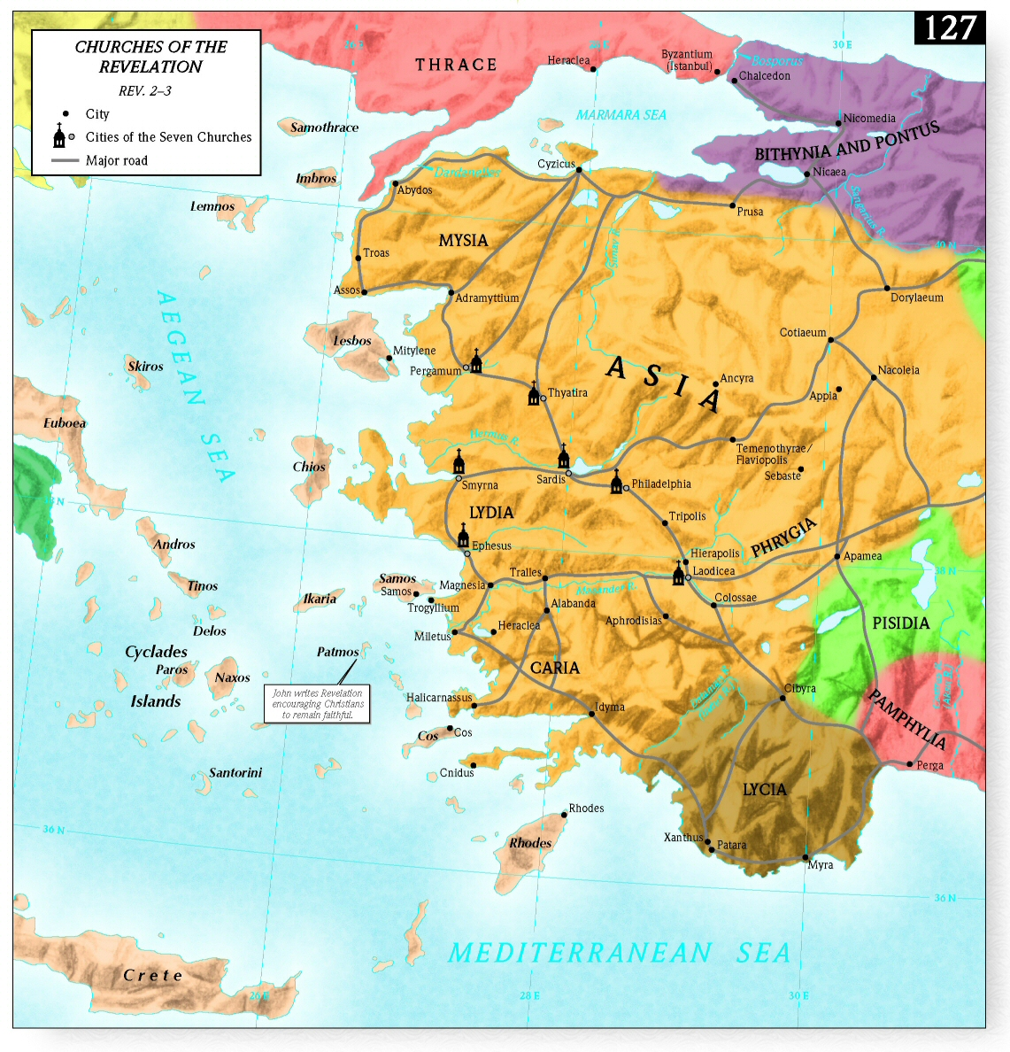
- Smyrna was an impressive harbor city with vital trade connections with Sardis. Renowned for its beauty and described by ancient writers as “the ornament of Asia,” Smyrna was located thirty-five miles north of Ephesus on a prominence overlooking the Gulf of Izmir. The faithfulness and allegiance of Smyrna to the Roman empire was so well know that it became a proverb. The aged bishop Polycarp, a disciple of the apostle John, would later suffer martyrdom in the stadium at Smyrna about 50 years later. Polycarp was asked to say “Caesar is Lord” and he refused. Emperor worship and allegiance to the emperor as the ultimate ruler was important in this city.
- The church in Smyrna was founded somewhere between 53-56 AD by Paul during his third missionary journey.
Address (v 8a)
- Jesus is still in the midst of the lampstands and He is still tending to His Church.
Christ’s Self-designation (v8b)
- Christ’s designation focuses on Him being the one who overcame death. Christ is the victor over death itself. This is going to be important because down in the promise Christ is going to talk about the church being faithful unto death.
Christ’s Commendation (vv9-10a)
- The Roman emperor was to be worshipped as a god and this was heavily enforced in Smyrna. The only ones excused from this emperor worship were Jews.
- So at first, Smyrna would have enjoyed protection as Christianity was seen as a Jewish sect. However, as the Church grows, the split grows wide and it becomes evident that Christianity is not Judaism.
- As a result, the church is experiencing extreme poverty as they are losing their jobs.
- William Hendricksen writes, “Becoming a Christian was, from an earthly point of view, a real sacrifice. It meant poverty, hunger, imprisonment, often death by means of the wild beasts or the stake.”
- But notice that in the midst of talking about their tribulation and poverty, there’s this little insert in parentheses that says “but you are rich.” They may be poor from an earthly perspective but from a heavenly perspective they are rich and that is what matters most. So don’t pity yourself or feel sorry for yourself because your Heavenly Father sees and knows and from His perspective you are rich while your persecutors are poor.
- Verse 9 says the church is being slandered by “those who say that they are Jews and are not, but are a synagogue of Satan.” So even those who are Jews by ethnicity are joining with the Romans against the Christians.
- True Jewishness comes from being in Christ.
- Romans 2:28-29a – “For no one is a Jew who is merely one outwardly, nor is circumcision outward and physical. ²⁹ But a Jew is one inwardly, and circumcision is a matter of the heart, by the Spirit, not by the letter.”
- Romans 9:6b-8 – “For not all who are descended from Israel belong to Israel, ⁷ and not all are children of Abraham because they are his offspring, but “Through Isaac shall your offspring be named.” ⁸ This means that it is not the children of the flesh who are the children of God, but the children of the promise are counted as offspring.”
- Verse 10 continues with the theme of tribulation and says that even more is coming. More suffering is coming your way so that you will be thrown in prison. And notice that it says “the devil” is the one throwing some of them into prison. The people who are doing this are identified with the devil because he is their father and they are doing his work.
- John 8:44 – “You are of your father the devil, and your will is to do your father’s desires.” Unbelievers are identified with Satan, but we are identified with Christ and just as Satan couldn’t overcome Christ, so opposition will not be able to overcome us.
- “The Jews who rejected Jesus professed to worship God, but their opposition to Christ showed that they were in fact under the control of satanic darkness (2 Cor. 4:4).” --Vern Poythress
- Smyrna was known for its faithfulness to the Roman emperor, but for the Christian the only faithfulness and allegiance that matters is loyalty to Christ above all earthly rulers and governments.
- Verse 10 also says that this tribulation is to test the church.
- James 1:2 – “Count it all joy, my brothers, when you meet trials of various kinds, ³ for you know that the testing of your faith produces steadfastness.”
- What satan brings in an attempt to cause Christians to compromise with the world or to flat out deny Christ, Christ intends to work more of His character into His own. Testing also will be used to distinguish between true believers and false believers – those seeds sown on rocky ground.
- Matthew 13:20-21 – “As for what was sown on rocky ground, this is the one who hears the word and immediately receives it with joy, ²¹ yet he has no root in himself, but endures for a while, and when tribulation or persecution arises on account of the word, immediately he falls away.”
Christ’s Condemnation (--)
- Notice that there is no condemnation for this church. When an element of a usual pattern is missing, that is significant. This does not mean Smyrna was perfect.
- A couple of reasons why a condemnation might be missing:
  - Christ highlights that they are currently suffering and will face more suffering and He wants to encourage perseverance rather than kicking them when they are down and subjecting them to possibly even more discouragement. In times of suffering, what Christ’s people need is grace and mercy, not law.
  - Their faithful witness is to such an extent or degree that Christ in His grace and mercy overlooks their faults because they are showing forth an excellent testimony in such hardship.
Christ’s Promise/Threat (v10b)
- Christ’s promise is that if you’re faithful in witness and testimony even at the cost of your life, He will give you the crown of life.
- James 1:12 – “Blessed is the man who remains steadfast under trial, for when he has stood the test he will receive the crown of life, which God has promised to those who love him.”
- Notice that it’s called the crown of life to those who endured death for Christ. Christ brings a reversal of the works of satan and his followers.
- The only reason we as the church could possibly be faithful unto death is because we follow the one who tells us that He has overcome death. Because He is victorious over the grave, we don’t have to fear going to the grave for Christ’s sake.
Christ’s Exhortation (v11a)
- Again this message goes beyond Smyrna to all churches, even today. But only the Spirit can give us the ears to hear what the Spirit is saying.
Christ’s Promise (v11b)
- If you persevere through this persecution, you will suffer the first death. All of us suffer the first death which is the death of our bodies. But the second death we will not suffer.
- Revelation 20:14-15 – “¹⁴ Then Death and Hades were thrown into the lake of fire. This is the second death, the lake of fire. ¹⁵ And if anyone’s name was not found written in the book of life, he was thrown into the lake of fire.”
Message for Us
- Christ is bigger than our suffering and will reward us for enduring and persevering in faithfulness.
- Our suffering is not in vain as Christ is still proclaimed to unbelievers and we are drawn closer to Him. God uses even our suffering to sanctify us and make us more Christlike.
- Times of non-suffering are great for preparing for suffering. God’s Word fortifies us so that when it rushes on we are prepared to withstand.

