A Recap of James
The Author: The book of James was written by the half-brother of Jesus. During Jesus’s public ministry, James did not accept him as the Messiah (John 7:5). His unbelief came to a screeching halt when Jesus appeared to him as the risen Lord (1 Cor. 15:7). After his conversion, James ascended rapidly in the leadership among the early Christians, becoming the head of the Jerusalem church. In that position, he joined with the apostles Peter and Paul in helping the Jerusalem Christians understand that Jews and Gentiles would be saved in the very same way—through Christ alone (Acts 15:11). James’s letter was written perhaps as early as AD 44. This would make it the earliest of all the New Testament books.
The letter shows that James had a pastor’s heart. He wrote from Jerusalem to Jewish believers who had been scattered by persecution. It is most likely that this was the persecution instigated by Herod Agrippa I (Acts 12). Known as ‘James the Just’ because of his righteous living, James encountered persecution himself, being put to death in AD 62, according to the historian Josephus.

Purpose: James is a book of exhortation. It is strong on application and practice. It is a handbook of ethics, so to speak, and the focus in particular is on how Christians conduct themselves toward each other. In other words, it is a Christian ethics manual for dealing with other Christians, not the world.

Commands: There are 62 commands in the Letter of James.

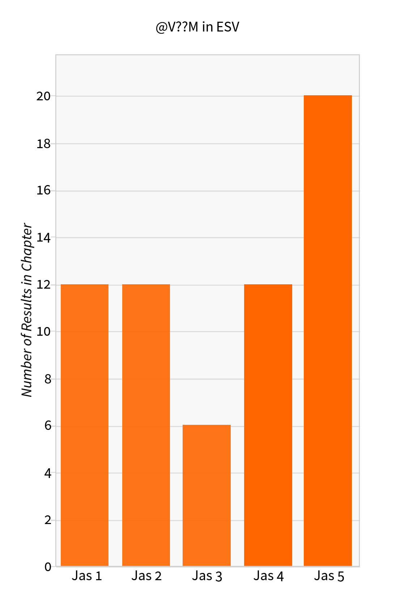

Our Attitudes/Understanding
1:2 – Consider it joy
1:4 – Let steadfastness have its full effect
1:7 – Don’t suppose you will receive if you doubt
1:16 – Don’t be deceived [concerning gifts of God]
1:19 – Know
1:19 – Be quick to hear
1:19 – [Be] slow to anger
1:21 – Receive the Word
2:5 – Listen [God has chosen poor to be rich in faith]
2:18 – Show me your faith apart from works [implied negative]
3:4 – Look at the ships [to understand our tongue]
3:5 – See how a forest is set on fire by a small flame
4:9 – Be wretched [over your desire to be worldly]
4:9 – Mourn [over your desire to be worldly]
4:9 – Weep [over your desire to be worldly]
4:9 – Let your laughter be turned to mourning [if you are worldly]
4:13 – Come now [understand you who arrogantly boast about the future]
5:1- Come now [understand you unbelievers]
5:4 – Behold [understand that your hoarding will testify against you]
5:7 – See [understand from the farmer who is patient]
5:9 – Behold [understand] the Judge is near
5:10 – Take [consider] the prophets as examples of suffering & patience
5:11 – Behold [understand] that those who remain steadfast are blessed
5:20 – Know [understand] that you affect a person’s soul when you draw them back from sin

Our Speech
1:5 – Ask God
1:6 – Ask in Faith
1:9 – boast in God exalting you
1:13 – Don’t say God tempts you
1:19 – [Be] slow to speak
2:12 – Speak as those who are judged under the law of liberty
3:14 – Do not boast
3:14 – Do not be false to the truth
4:11 – Do not speak evil against one another
5:9 – Do not grumble against one another
5:12 – Do not swear by created things
5:12 – Your yes is to be yes and your no is to be no
5:13 – Pray in suffering
5:13 – Sing praise in times of cheerfulness
5:14 – Call for the elders in times of extreme sickness
5:14 – Elders pray for those who call you to pray for them
5:16 – Confess your sins to one another
5:16 – Pray for one another that you may be healed

Our Actions
1:22 – Be doers of the Word
2:1 – Don’t show partiality in the faith
2:3 – Don’t command the rich to places of honor and the poor to places of humility
2:12 – Act as those who are judged under the law of liberty
2:24 – See that a person is justified by works and not faith alone
3:1 – Not many should become a teacher
3:13 – Show your works in meekness of wisdom
4:7 – Submit to God
4:7 – Resist the Devil
4:8 – Draw near to God
4:8 – Cleanse your hands
4:10 – Humble yourself before God
5:7 – Be patient until the coming of the Lord
5:1 – Weep [you unbelievers for the coming judgment of God]
5:8 – Be patient
5:8 – Establish [Strengthen] your hearts

What is some application from these observations and categories?
- All of these commands at their heart are applications of the 10 Commandments.
- We need to see just how badly we fall short of the glory of God. We can’t even keep these commands perfectly, let alone commands in the rest of Scripture.
- We need to keep our eyes and trust more firmly fixed upon Jesus.
- God cares about both our inner person and our outer person.
- God cares about how we treat each other in the Body of Christ.

Major Themes:
- A High View of the Old Testament and OT Moral Law (10 Commandments)
  - James 1:25 – “perfect law” and “law of liberty” = OT moral law in light of the Gospel message
  - James 2:8 – royal law = “you shall love your neighbor as yourself” (see Lev. 19:18)
  - James 2:11 – “do not murder”, “do not commit adultery”
  - James 2:12 – “law of liberty”
  - James 2 – Abraham demonstrated faith, Rahab demonstrated faith
  - James 4:2 – murder and coveting
  - James 4:6 – “God opposes the proud but gives grace to the humble.” (See Prov. 3:34)
  - James 5 – Be patient like Job, pray like Elijah
  - James draws from the OT law, OT wisdom, and OT prophetsThe 3 major divisions of OT Scripture.
  - James understands that the 10 Commandments still apply to the church because they reflect God’s character. This is what the Reformed have called “The 3rd use of the Law.” God’s Law is our guide for Christian living. The Law is our friend if we are in Christ.
- Poverty/Wealth
  - James 1:27 – pure religion is “to look after orphans and widows in their distress”
  - James 2:1-5 – God has chosen the poor in the eyes of the world to be rich in faith
  - James 2:15 – “Suppose a brother or sister is without clothes or daily food….”
  - James 5:1 – “Listen you rich people, weep and wail because of the misery that is coming upon you.”
  - James is concerned for how we treat the family of God. If we can’t take care of our own, what kind of testimony is that to a unbelieving world?
- The Relationship Between Justification by Faith and Works (Demonstrating Faith)
  - James 1:22 – Be doers of the Word and not hearers only
  - James 4:17 – Whoever knows the right thing to do and fails to do it, it is sin
  - James 2:14-26
  - Remember, James is saying that true saving faith brings with it the good works that God has prepared beforehand. Salvation is not by faith plus works. Salvation is by faith alone and our good works proceed out of a regenerated heart. James is comparing the nature of “faith” (true faith vs. dead faith) whereas Paul is talking about what saves (faith alone)
  - Saving faith is not knowledge alone or a mere verbal profession. Saving faith drives us to live out our faith in obedient actions.
- God
  - His Oneness
    - James 2:19 – God is one (monotheism)
    - James 2:8-11 – The oneness of the Law reflects the oneness of God
    - James 4:11 – God is one Judge and Lawgiver
  - His jealousy
    - James 4:5 – God is righteously jealous over exclusive attention from His people because He has caused His Spirit to dwell within us
  - His grace
    - James 4:6 – God gives more grace
- Wisdom
  - James 1:5-8 – Ask for wisdom from God who gives it generously
  - James quotes from or alludes to Proverbs 10:19, 11:28, 14:29, 15:18, 18:5
  - James draws from themes found in Proverbs – speech, emotions/attitudes, quarrels, etc.
- James and the Teaching of Jesus
  - Love of neighbor is a great command (James 2:8 & Matt 22:39)
  - Self-exaltation leads to humiliation (James 4:6-10 & Matt 23:12)
  - Oath taking (James 5:12 & Matt 5:33-37)
  - Do not judge (James 4:11-12 & Matt 7:1-5)
  - Moth and rust destroy riches (James 5:2 & Matt 6:19)
  - The Lord is coming, even at the door (James 5:8-9 & Matt 24:33)

