Revelation
Lesson 11 – Revelation 3:7-13
- The addresses to the 7 churches all follow the same basic pattern:
- Address – “to the angel of the church….write”
- Christ’s Self-designation – “the words of…..”
- Christ’s Commendation – “I know….” something positive about the church
- Christ’s Condemnation – “But I have this…..against you…..” something negative about the church
- Christ’s Promise or Threat – “I will….” or “remember….or else”
- Christ’s Exhortation – “He who has an ear, let him hear what the Spirit says to the churches”
- Christ’s Promise – “to the one who conquers…..” something good Christ promises
The Church in Philadelphia (3:7-13)
- Neither archaeological work nor the words of classical authors provide much information about the city. Located on a tributary valley of the Hermus River southeast of Sardis, Philadelphia was near a volcanic zone susceptible to earthquakes. The city suffered severely in an earthquake in A.D. 17. One ancient writer described Philadelphia as “full of earthquakes, for the walls never cease being cracked.” Emperor Tiberius furnished funds to rebuild Philadelphia and other cities damaged by the earthquake; Philadelphia added Neo-caesarea to her name in gratitude. Vineyards flourished in the volcanic soil near the city. Nothing remains of the numerous temples that once adorned the city described by pilgrims and depicted on coins.
- 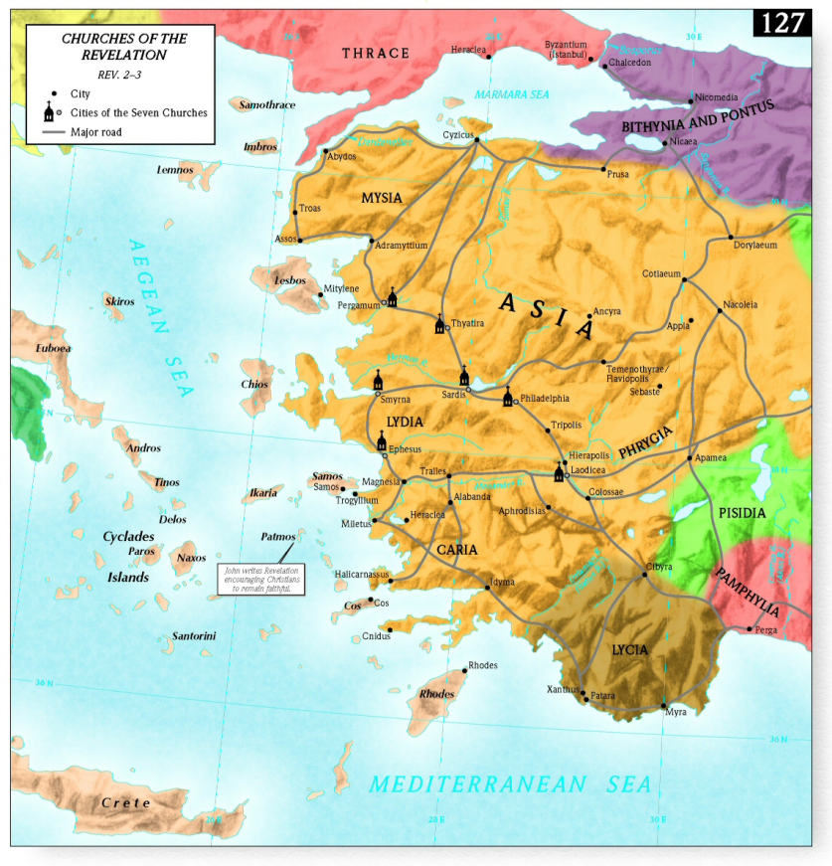
Address (v 7a)
- I’ve already discussed the possible options about this being a real guardian angel over the church or the minister of the church. Regardless, Jesus is still in the midst of the lampstands and He is still tending to His Church.
Christ’s Self-designation (v7b)
- Holy One: In His holiness, Christ gathers His church and sanctifies her, to make her holy and without blemish in the sight of His holy Father.
- True One: He is the true one in the sense of being real and not counterfeit or a pretender (unlike the Jewish synagogues in verse 9). But Christ is also true in the sense that He is faithful to keep His promises
- Key of David and the Authority of the Keys:
  - Isaiah 22:22 – “And I will place on his shoulder the key of the house of David. He shall open, and none shall shut; and he shall shut, and none shall open.”
  - Matthew 16:19 – “I will give you the keys of the kingdom of heaven, and whatever you bind on earth shall be bound in heaven, and whatever you loose on earth shall be loosed in heaven.”
Christ’s Commendation (v8)
- What is this “little power/strength”? It could refer to the small size of the church, the low standing in society of the church, the relative poverty of the church, or a combination of these things.
- The church in Philadelphia is described as having “little power/strength” but Christ has the highest and greatest power by having the authority of the keys of the kingdom of God. Though they have “little power” Christ has opened the door for them into the kingdom and nobody is powerful enough to close shut that door against them.
- Colossians 4:3 – “At the same time, pray also for us, that God may open to us a door for the word, to declare the mystery of Christ…”
- Despite their “little power,” Christ commends them because they have kept His word and not denied His name. Despite opposition from both Romans and Jews, they remained steadfast and immovable, persevering in the work of the Lord.
- This is just like the church in Smyrna where there was no condemnation, only commendation. Christ’s commendation is not dependent on how big your church is, or how many programs your church has, but on how faithful the church is.
Christ’s Promise/Threat (vv9-11)
- Just like in the message to Smyrna, ethnic Jews are again called a “synagogue of Satan” not because of their ethnicity but because they actively rejected Christ and opposed the works and message of His Church.
- Again, a true Jew is not one outwardly, but one inwardly through Jesus the Messiah and Holy One of Israel.
- Romans 2:28-29a – “For no one is a Jew who is merely one outwardly, nor is circumcision outward and physical. ²⁹ But a Jew is one inwardly, and circumcision is a matter of the heart, by the Spirit, not by the letter.”
- But Christ is going to reverse the situation from one of opposition, to one of humility by conversion! Christ is going to convert many Jews who are currently opposed to the church through that door that He has opened for His faithful church.
- “Even though the church appeared to have only a ‘little power’ in comparison to the greater strength of the city’s pagan and Jewish communities, God would nevertheless cause the church’s witness to be powerful, especially among the Jews.” --Greg Beale
- “All of us wish that a door would open for us and others, such as friends, relatives, and work associates. We have been evangelizing some of them for years. But the door doesn’t open automatically. Even if you have the right methods, the right approach, the right time, and the right manpower, gifts, talents, and personality, salvation doesn’t come automatically. People can be saved only if Christ opens the door.” –Joel Beeke
- Verse 10 – Christ will continue to protect His church spiritually from the tribulation that is about to come. “Those dwelling on the earth” is a technical phrase in Revelation to refer to unbelievers and idolaters. So God is going to judge the world, but He is going to preserve His church. This is a spiritual protection.
- John 17:15 – “I do not ask that you take them out of the world, but that you keep them from the evil one.”
- Verse 11 – Christ gives encouragement to keep on as you are. Cling to Christ and being a faithful witness and your crown will not be lost. Notice the balance between God’s sovereignty and human responsibility. Christ will keep them from the hour of trial, nevertheless they are to hold fast to what they have.
Christ’s Promise (v12)
- 4 different aspects of the same promise are given:
  - A pillar in the temple of my God – If you persevere, Christ promises to build You into His dwelling place in such a way that you become structurally significant and permanent.
  - The name of My God
  - The name of the city of My God
  - My own new name
- Ezekiel 48:35 – “And the name of the city from that time on shall be, ‘The Lord Is There.’”
- Revelation 14:1 – “Then I looked, and behold, on Mount Zion stood the Lamb, and with him 144,000 who had his name and his Father’s name written on their foreheads”
- Revelation 22:4 – “They will see His face, and His name will be on their foreheads”
- All of these references point toward God’s people dwelling in His very presence with His seal set upon them. Christ knows His own because He has marked them with His own name which sets them apart from those who do not know Him and do not have His name written on them.
- The name of God means we will reflect His character and be completely sanctified and made pure. The name of the city of God means we will be united as one family, with no division, hard feelings, or differences of opinion. And the name of Christ means we will identify with Him in His victory and in His ruling and reigning as Prophet, Priest, and King.
Christ’s Exhortation (v13)
- Again this message goes beyond Philadelphia to all churches, even today. But only the Spirit can give us the ears to hear what the Spirit is saying.
Message for Us
- How faithful are we to hold fast to the Word of God and to proclaim it to others? Joel Beeke calls this church “the favored church” and it’s all based on faithfulness. If we want God’s favor in Christ Jesus, then we need to be faithful as His people to obey all that He commands us. We obey Him privately in our personal lives – pursuing holiness – and we obey Him publicly by proclaiming Jesus Christ.
- Philadelphia was the only one of the seven cities of Revelation where Christianity lasted. Robert Murray M‘Cheyne said that in the nineteenth century, Philadelphia, with a population of two thousand people, still had eight hundred professing Christians in its five churches.
- To a faithful church, Christ promises victory, safety, and endurance.

