Revelation
Lesson 12 – Revelation 3:14-22
- The addresses to the 7 churches all follow the same basic pattern:
- Address – “to the angel of the church….write”
- Christ’s Self-designation – “the words of…..”
- Christ’s Commendation – “I know….” something positive about the church
- Christ’s Condemnation – “But I have this…..against you…..” something negative about the church
- Christ’s Promise or Threat – “I will….” or “remember….or else”
- Christ’s Exhortation – “He who has an ear, let him hear what the Spirit says to the churches”
- Christ’s Promise – “to the one who conquers…..” something good Christ promises
The Church in Laodicea (3:14-22)
- Laodicea was one of three cities founded in the fertile Lycus Valley. It was the key city of the wealthy province of Phrygia. In addition to being a banking center, Laodicea was known for its textile industry based on a rich black wool from sheep raised in the valley. A medical school widely known for an eye salve also brought fame and wealth to the city. Inscriptions and coins mention numerous deities worshiped at Laodicea including the one honoring the city’s chief deity, Zeus.
- 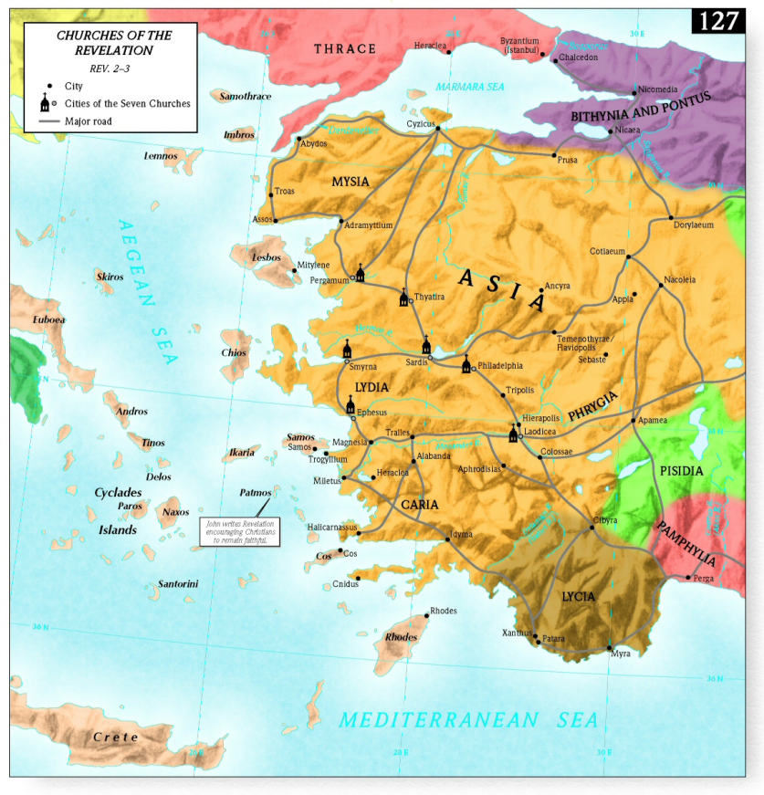
Address (v14a)
- I’ve already discussed the possible options about this being a real guardian angel over the church or the minister of the church. Regardless, Jesus is still in the midst of the lampstands and He is still tending to His Church.
Christ’s Self-designation (v14b)
- Christ reminds this church that He is the truth and his words/testimony/witness are true and reliable. Now this relates to the situation in the Laodicean church because they have one view of themselves, but Christ the exact opposite view of the Church. Who are you going to trust – your own self-evaluation or Christ’s evaluation of you?
- What does it mean that Christ is “the beginning of God’s creation”?
- Isaiah 65:15-17 talks about God who is the “God of truth” but then it begins to talk about the creation of the new heavens and the new earth.
- Isaiah 43:10-12 says that God and Israel are “faithful witnesses” to the new creation.
- Christ is saying He is the beginning of God’s new creation – salvation and redemption of people and the beginning of restoring the world and redeeming it from sin. This is equivalent to “the firstborn of the dead” found in Revelation 1:5 right after the phrase “the faithful witness.” Jesus inaugurates a new creation and thus is the beginning in Himself.
Christ’s Condemnation (vv15)
- This was a city full of bankers, millionaires, the upper class, etc. and thus the church was full of such people.
- “The citizens of Laodicea were rich – and they knew it! They were unbearable. Even the church people manifested this same proud, defiant, conceited attitude. Perhaps they imagined that their wealth was a sign of God’s special favor. At any rate they began to think that they were ‘all it.’” –William Hendricksen
- Christ says He knows their works and those works are neither hot nor cold.
- What is meant by “cold works”?
  - It could represent the state of being unconverted.
  - It could represent the state of being refreshing to people like cold water is.
  - It could represent ineffective witness that brings neither spiritual healing nor life from believers.
- What is meant by “hot works”? Enthusiasm, zeal, commitment
- “Laodicea’s water supply had to be provided from a distant source through pipes. The resulting water was lukewarm and barely drinkable. By contrast, the neighboring town of Hierapolis had medicinal hot springs, and neighboring Colossae was supplied by a cold mountain stream. Church urges the church to be refreshing (cold) or medicinally healing (hot), rather than like the Laodicean water supply.” –Vern Poythress
Christ’s Promise/Threat (vv16-20)
- This moves us to verse 16 where Christ says that He finds a half-way church so disgusting He likens it to their vulgar and disgusting water that nobody wanted to drink. In essence, the church at Laodicea was useless and disgusting.
- How is this lukewarmness revealed? Lack of witness (verse 14), Spiritual self-sufficiency (verse 17), Trusting in riches (verse 17), Blindness to one’s true spiritual condition (verse 17), Lack of zeal (verse 19)
- This is a church that is proud, thinks they have it all, thinks that they don’t need to do anything, but Christ’s evaluation is exactly the opposite and He’s the truthful and faithful witness.
- Israel used to pride itself in that material wealth was a sign of spiritual wealth. Hosea 12:7-8 – “A merchant, in whose hands are false balances, he loves to oppress. Ephraim has said, “Ah, but I am rich; I have found wealth for myself; in all my labors they cannot find in me iniquity or sin.”
- This ends up being a contrast between the church at Smyrna which was materially poor but spiritually rich with Laodicea which was materially rich but spiritually poor.
- Verse 18 admonishes the church at Laodicea to seek spiritual riches, not worldly gold, and to anoint their eyes with spiritual salve (drawing upon the well-known eye salve produced in the city for its healing properties). Refined gold refers to purifying one’s life by removing sin.
- Zechariah 13:9 – “And I will put this third into the fire, and refine them as one refines silver, and test them as gold is tested. They will call upon my name, and I will answer them. I will say, ‘They are my people’; and they will say, ‘The LORD is my God.’ ”
- And Christ’s motivation in saying this to His church is because He loves His church, verse 19. He wants His church to stop being lukewarm so He invites them to come to Him, repent, and find true, spiritual wealth.
- And for all of those who come to Him, they get to enjoy sweet and filling fellowship with Him, verse 20. And notice the contrast here. For those who repent and renounce their self-sufficiency and complacency, instead of being spit out of Christ’s mouth, they will get to eat and enjoy food with Him.
- Vern Poythress writes of verse 20, “[It] has often been used as an evangelistic text, but in its original context it is a promise directed at complacent Christians, who need to confess their dependence and restore fellowship with the Master.” It’s a picture of Christ being outside the Church when He should be in her midst.
Christ’s Promise (v21)
- This promise is similar to the promise to the church at Thyatira those who overcome will be given authority by Christ to rule the nations with a rod of iron. Christ shares His authority with those who are His own just as the Father shares His authority with the Son.
- “Christ promises that if those in the church resist taking a low profile in their witness, they will inherit a ruling position with him.” –Greg Beale
Christ’s Exhortation (v22)
- Again this message goes beyond Laodicea to all churches, even today. But only the Spirit can give us the ears to hear what the Spirit is saying.
Message for Us
- There was nothing to commend in a church that was lukewarm. “Jesus Christ is either worth everything or He is worth nothing. If He is the true Savior and Lord—the way, truth, and life—as He claims to be, He is worth everything. He is worthy to be served with our entire soul, entire mind, and entire strength. If He is not what He claims to be, then, God forbid, He is an imposter, a sham, a fake—and He is worth nothing. It is impossible that Jesus is only worth something. He either deserves your whole heart or none of your heart. It makes no sense at all to give him only half your heart. The Bible tells us repeatedly that He despises half-hearted religion; He is disgusted with lukewarmness.” –Joel Beeke
- “We, too, can easily pretend that we’re all right. We do that when we think we’re not quite as bad as our neighbors or not quite as bad as the Word of God says we are.” –Joel Beeke
- “Nothing dishonors Christ more in the eyes of the world than a self-satisfied church. Such a congregation preaches the gospel of grace to needy sinners, but lives as if it has no spiritual needs. It tells people that they are guilty sinners, but acts as if it had no guilt of its own for Christ’s blood to cover. It calls people to pray for salvation, but cannot rouse itself to come to a prayer meeting to cry out for divine mercies. A self-satisfied church is a living contradiction to the gospel of Christ.” –Joel Beeke

