Revelation
Lesson 14 – Revelation 4:6b-11
- When we are tempted to speak and act as if the control of events and the destiny of the world rested in the hands of men instead of God, Chapter 4 ushers us into the throne room of God to behold the world from an eternal perspective in which God reigns in all matters, large and small, with absolute authority.
- “The occupied throne is the focus of this second cycle of visions. Seventeen times in Revelation 4 and 5, John speaks about this throne. All other symbols, such as colors, numbers, and pictures, should be understood in relation to this throne”. –Joel Beeke
 | Daniel | Revelation
Vision Introduction | 7:9 | 4:1
A throne in heaven | 7:9a | 4:2a
God sitting on a throne | 7:9b | 4:2b
God’s appearance on the throne | 7:9c | 4:3a
Fire before the throne | 7:9d-10a | 4:5
Heavenly servants surrounding the throne | 7:10b | 4:4b, 6b-10
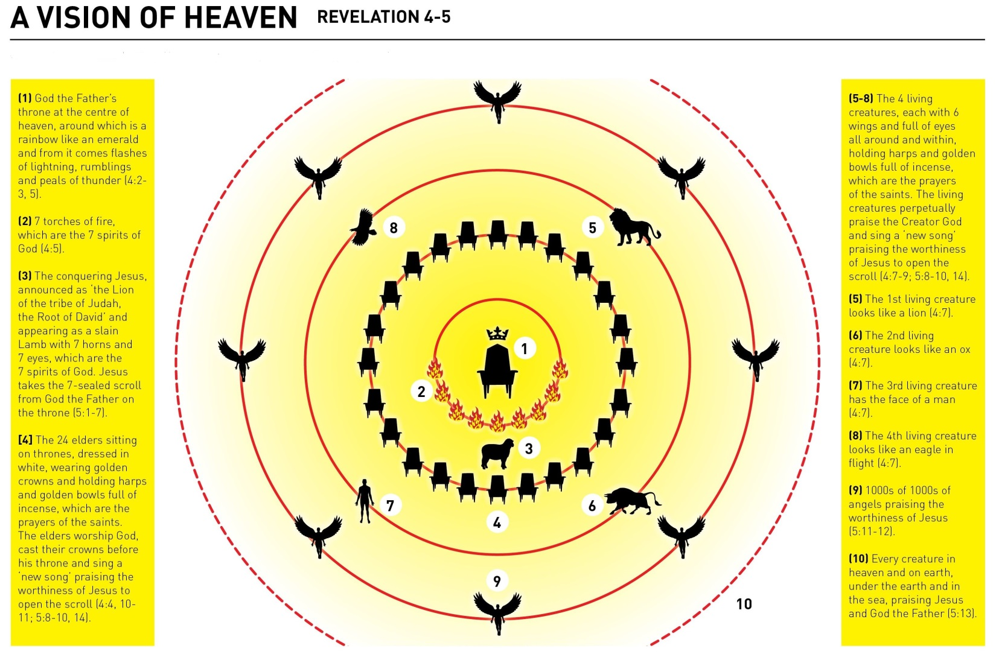
Verses 6b-7: 4 Living Creatures
- These creatures are located on the middle of each side of the throne – one in front, one on each side, and one in the back.
- In all likelihood these are angels of the highest order whose eyes represent that they are constantly aware and alert and full of knowledge so that nothing gets by them.
- Compare these creatures to Ezekiel 1:4-14. Same animals are described on their faces, and there are 4 of them and they have eyes all over. One difference is that these creatures are only described as having 4 wings. If you continue reading Ezekiel, these living creatures are pulling the throne-chariot of God Almighty and going wherever He wants to go over all of creation. These creatures reappear in Ezekiel 10 as well.
- “In the Bible, cherubim function both as guardians of God’s holiness (Gen 3:24; Exod 25:17-22; 26:31) and as chariot-bearers of His throne (1 Chron. 28:18; Ps 18:10). The cherubim in the OT are closely associated with God’s chariot, going with the swiftness of the wind. They are, as it were, the heavenly original of which earthly winds are an image. They are 4 in numbers, corresponding to the four winds of heaven in the four directions of the compass (Zech. 6:5; Rev 7:1). Their eyes, seeing in every direction, mirror the all-seeing eyes of God (Rev 1:14; Prov 15:3; 2 Chron 16:9).” –Vern Poythress
- Isaiah 6:2 – “Above him [the Lord] stood the seraphim. Each had six wings: with two he covered his face, and with two he covered his feet, and with two he flew.” Isaiah doesn’t describe their faces because they are covered in his vision, but the seraphim Isaiah sees have the same number of wings as the 4 living creatures in Revelation. Additionally, the seraphim in Isaiah sing, “Holy, holy, holy is the Lord of hosts” (Isa 6:3) and the 4 living creatures in Revelation sing, “Holy, holy, holy is the Lord God Almighty” (Rev 6:8)
- Why are they depicted as these 4 creatures – man, ox, eagle, and lion – in particular? Vern Poythress suggests the lion because it is the greatest and fiercest of the wild animals, the ox the strongest of domesticated animals the eagle as most majestic of birds, and man as the ruler over all animals. William Hendricken suggests the lion because of its strength, the ox who renders service, the swiftness of the eagle, and the intelligence of man. Beale suggests they represent the whole created order of “animate” (animal and human) life.
- “So great is the throne [of God] that even the all-glorious and holy cherubim arrange themselves around it in reverence, humility, and awe, ever ready to carry out the will of the Sovereign of the universe.” –William Hendricksen
- “These ‘living beings’ are an encouragement to keep persevering under persecution, knowing that God is acutely aware of their plight and is already in the process of taking action in their favor and against their persecutors (as chapters 6 and following reveal).” –Greg Beale
Verses 8-11: Worship
- In verse 8, I want you to notice the pattern of their worship. They praise God day and night. The Old Testament sacrifices were patterned morning and evening. Hence, I believe that the Sabbath day is truly honored when there is both morning and evening worship.
- In verses 8 and 11 we see the content of their praise. They worship God for His holiness, His eternality (was, is, and is to come), His worth, being our God (our Lord and God), His praise (receive glory, honor, and power), His work of creation, His decree and providence (by Your will they existed and were created).
- “As Creator, God has absolute mastery, ownership, and control over what He has created. In creation, every speck, every atom, every detail of pattern, the very being of everything, derived from the hand of God. His triumph was absolute, His power and wisdom unfathomable, His glory superb. Such, then, are so many displays of God’s character in creation. They form a wonderful guarantee that He will continue to be Master, up until the full achievement of His purposes in the consummation.” –Vern Poythress
- And in verses 9-10, we see the congregation worshipping. When the 4 living creatures bow down in praise and worship, the 24 elders get off their thrones, fall before the Lord, cast their crowns as His feet, and join in the same worship. The 24 elders (representing the OT & NT church) and the 4 living creatures (representing angels and all of creation) join together corporately in praising God.
- The main point of this section, says Greg Beale, is that “God is to be glorified because of His holiness and sovereignty.” So in heaven and on earth, by angels and all of creation, God is to be praised and who He is, is to be exalted.
- “These worshipers experience such satisfaction, joy, and pleasure because their eyes are fixed upon the One who is seated on the throne. You can experience the true joy of worship only when your worship is centered upon the triune God and when the presence of the Lord evokes in you the joy of the amazing privilege of knowing Him and being known by Him.” –Joel Beeke
Message for Us
- If the centrality of God’s sovereignty and corporate worship in the heavenly throne room (Rev 4) is what we need to encourage us and comfort us and help us persevere in the midst of all the problems that go on in the churches while in this world (Rev 2-3), then we should make corporate worship on Sunday a priority. We come week after week having dealt with our own sins and the sins of others and how it affects us, and the motivation to keep on and to be spiritually cheered, and to know afresh the forgiveness of sins and the depths of God’s mercy and grace in Jesus Christ, is found in the corporate worship of God by His people.
- This passage right here should inform our theology of worship in the Church. Much of what passes today as worship is mere entertainment and is more focused on us than it is about God. But also when we get caught up in the worship wars, many times it’s more about our preferences, so we too can be guilty of making worship about ourselves rather than about God.
- John’s vision originating from the Spirit of God draws upon the OT books of Daniel, Ezekiel, Isaiah, Zechariah, et. al. Are these books that the church corporately and individually studies or are they largely ignored? The largeness of particular books should not scare us. Neither should the strangeness or foreignness of the books scare us away from reading them, studying them, preaching from them, applying them to our lives.
- If heaven is depicted as being about all of creation worshipping God, then we should be zealous for the worship of God both publicly in the corporate gathering of the church and privately in our homes.

