Revelation
Lesson 40 – Revelation 21:9-21
- About a decade ago, a video on Youtube went viral where a guy stood gazing in absolute awe and wonder at a double rainbow for over 3 minutes. This section of Revelation, which describes the New Jerusalem, is meant to inspire in us awe and wonder at the beautiful description of God’s people.
Verses 9-14: The Layout of New Jerusalem
- One of the 7 angels from the Bowl Judgments in Revelation 15 speaks to John and says he will show John “The Bride, the wife of the Lamb,” but what John sees in verse 10 is “the holy city Jerusalem coming down out of heaven from God.” The Bride of Christ – the Church – is symbolically pictured as a city. And the first thing John notices about this city is verse 11, this city has the glory of God, a radiance shining about it. This glory indicates majesty, awesomeness, and the beauty of God. Those who are in close association with God also have God’s radiant brightness shine around them. Paul is blinded by a bright light, brighter than the sun, when he meets the Risen Jesus on the way to Damascus. Moses came down from Mount Sinai and had to veil his face because it shone so brightly after seeing the glory of the Lord pass by him (Exodus 34:29-35).
- One thing that we can easily miss in verse 9 is the parallel with Revelation 17. In Revelation 17, “one of the 7 angels who had the 7 bowls came” and that angel shows John the fall of the city of Babylon. Here, “one of the 7 angles who had the 7 bowls full of the 7 last plagues” shows John the descent of the city of Jerusalem out of heaven. It appears that the same angel shows John the fall of the symbolic city of wickedness and the rise of the symbolic city of righteousness. This shows that the city of Babylon which held the old heavens and earth captive and ruled over it has been replaced in the new heavens and earth by the city of Jerusalem. Sam Storms says, “One is a harlot, a prostitute, an idolatrous and unfaithful woman who rebels against God. The other is a beautiful bride, a faithful wife who adores her husband and lives in perfect and unbroken intimacy with her bridegroom.”
- The reflection of the radiance of God’s glory is likened, in verse 11, to jasper. In Revelation 4:3, God sitting on His throne is described as having the appearance of jasper. We also see in verses 18-19 of this chapter that the walls of the city are built of jasper and one of the foundation jewels is jasper. From top to bottom the symbolic city New Jerusalem reflects the bright radiance of God Himself. Ezekiel 43:4-5 – “As the glory of the Lord entered the temple by the gate facing east, ⁵ the Spirit lifted me up and brought me into the inner court; and behold, the glory of the Lord filled the temple.”
- The layout is that the city is surrounded by a single high wall and there are 12 gates, 3 on each side of the city. So the city is pictured as a cube. On each gate is written the name of one of the 12 tribes of Israel and there is an angel stationed at each gate.
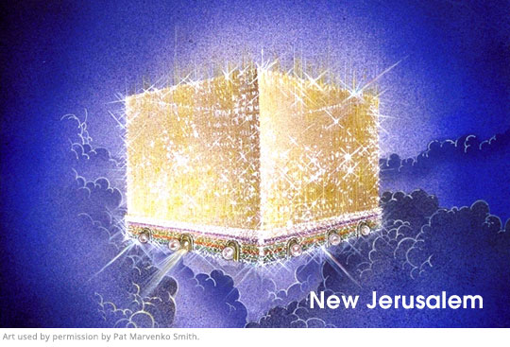
Ezekiel 48:30-35 – “These shall be the exits of the city: On the north side, which is to be 4,500 cubits by measure, ³¹ three gates, the gate of Reuben, the gate of Judah, and the gate of Levi, the gates of the city being named after the tribes of Israel. ³² On the east side, which is to be 4,500 cubits, three gates, the gate of Joseph, the gate of Benjamin, and the gate of Dan. ³³ On the south side, which is to be 4,500 cubits by measure, three gates, the gate of Simeon, the gate of Issachar, and the gate of Zebulun. ³⁴ On the west side, which is to be 4,500 cubits, three gates, the gate of Gad, the gate of Asher, and the gate of Naphtali. ³⁵ The circumference of the city shall be 18,000 cubits. And the name of the city from that time on shall be, ‘The Lord Is There.’” Ezekiel’s vision of the renewed temple is a cube with 12 gates, 3 on each side, with the names of the tribes of Israel written on it. John is seeing Ezekiel’s temple, but now the temple is called a city and a Bride. The people of God are variously called a Temple, a Bride, and a City. Zechariah 2:5 – “And I will be to her a wall of fire all around, declares the LORD, and I will be the glory in her midst.’” The wall represents God’s defense of his people and their dwelling in absolute safety and security forevermore.
- The wall has 12 foundations upon which are written the names of the Apostles (including John!). Back in Revelation 4 I argued that the 24 elders around the throne of God represent the entire people of God both from the Old Testament (12 tribes) and the New Testament (12 apostles). We saw in Revelation 7 that the entirety of God’s elect is pictured as 144,000 (12,000 from each tribe times 12 apostles). Here is another picture of all saints from both the Old Testament and the New Testament dwelling together. Ephesians 2:19-21 – “you are fellow citizens with the saints and members of the household of God, ²⁰ built on the foundation of the apostles and prophets, Christ Jesus himself being the cornerstone, ²¹ in whom the whole structure, being joined together, grows into a holy temple in the Lord.”
Verses 15-21: The Luster of New Jerusalem
- An angel begins to measure the city with its gates and wall with a measuring rod made of gold. In Ezekiel 40:3-5, Ezekiel is set down “on a very high mountain, on which was a structure like a city” and there is a man there with “a measuring reed in his hand” who begins to measure the city that Ezekiel sees. Both Ezekiel and John see the city being measured, which symbolizes integrity and security. God is placing boundaries around the city to keep it protected from harm and the entrance of any evil. In Revelation 11, the outer court of the temple was not measured which left it vulnerable to attack. Now the new Jerusalem is no longer vulnerable to attack from anything. Zechariah 2:1-2 – “And I lifted my eyes and saw, and behold, a man with a measuring line in his hand! ² Then I said, “Where are you going?” And he said to me, “To measure Jerusalem, to see what is its width and what is its length.”
- In verse 16, we’re told that the length, width, and height of the city are the same – 12,000 stadia. That is roughly 1,400 miles. Again we have the number 12 (apostles or tribes of Israel) times 1000 (a number of completeness). Even its walls are 144 cubits (12x12) which is roughly 216 feet. It’s not clear if this is the thickness of the wall or its height. Regardless, this is an immensely huge and perfectly cube city.
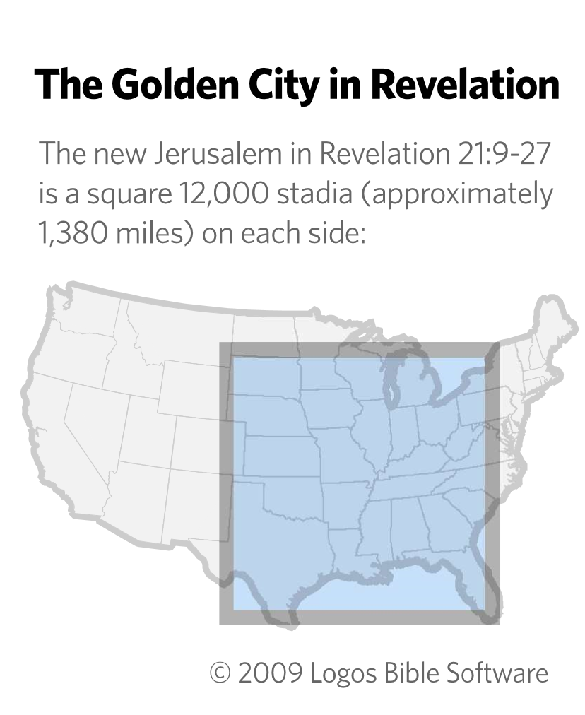
- Additionally, the Holy of Holies of Solomon’s temple was a perfect cube of 20 cubits (1 Kings 6:20). The Holy of Holies has become an immensely large city-temple where God dwells with all of His elect saints in perfect security and dazzling radiance!
- Then the luster of the city is described. The city is pure gold, like Solomon’s temple which was overlaid with gold (1 Kings 6:20-22). The foundations of the wall have 12 distinct jewels adorning them. This reflects the beauty and glory of God’s holiness. We see jasper listed again in verse 19 as the first jewel. This list of jewels is based on the 12 stones that are in the high priest’s breastplate (Exodus 28:17-20; 39:8-14). 9 of the stones between the lists are the same (topaz, sapphire, emerald, jacinth, agate, amethyst, beryl, onyx, jasper) and 3 are possibly the same or related (sardius/carbuncle/diamond vs. carnelian/chrysolite/chrysoprase). What the high priest represented is now extended to the entire city. It is a priestly city full of a kingdom of priests.
- If we think about all of these colors, you get something like a rainbow appearance. In Revelation 4:3, the throne of God was encircled by a rainbow, which is the sign of God’s covenant with Noah. This New Jerusalem will never be destroyed.
- Each gate is made of a single pearl. Now if the wall is 216 feet high or 216 feet thick, that’s an enormous pearl and must come from a giant oyster if this is all to be taken literally. Remember, this is a vision and using symbolic language to represent what is going on. Its streets are pure gold, and are transparent like glass, which symbolizes dazzling beauty and reflective radiance of God’s glory.
Message for Us
- “Priests in the OT were to keep temples clean from defilement. Now that believers are part of the temple in this age, they are to keep the temple from sinful defilement. To the degree that we do this, God’s glorious tabernacling presence will shine increasingly through us.” –Greg Beale
- Though our bodies (the physical side of the church’s temple) is not protected in this age and we are subject to disease, persecution, and death, our souls (the spiritual side of the church’s temple) are already kept from harm and evil cannot threaten our soul with utter destruction for all those who belong to God. In the New Jerusalem, already existing spiritual security will be joined with physical security so that God’s people enjoy complete security forever.
- “That ancient serpent somehow insinuated himself into the Garden of Eden, God’s earthly Paradise. There were no walls to keep him out. But around the heavenly Jerusalem and the church of Christ, there is a great, high, thick wall. The point is surely this: there is no possibility whatsoever of Satan or any other enemy invading the new creation. No one uninvited will get into New Jerusalem. The walls of God’s truth and justice will keep them out. We are better off than Adam if we are in Christ. We are safer than he was, thanks to the work of our second Adam.” –Joel Beeke
- “We are living in days when the foundations of the church are being undermined. Though there is no other foundation than Christ Jesus, some liberals embrace a Christ who has little or nothing to do with the Bible. We need to remember from John’s vision that the foundation of the church is the Christ of Scripture, as attested by His chosen apostles. The true church is apostolic in doctrine, worship, order, and life.” –Joel Beeke

