Revelation
Lesson 8 – Revelation 2:12-17
- The addresses to the 7 churches all follow the same basic pattern:
  - Address – “to the angel of the church….write”
  - Christ’s Self-designation – “the words of…..”
  - Christ’s Commendation – “I know….” something positive about the church
  - Christ’s Condemnation – “But I have this…..against you…..”
  - Christ’s Promise or Threat – “I will….” or “remember….or else”
  - Christ’s Exhortation – “He who has an ear, let him hear what the Spirit says to the churches”
  - Christ’s Promise – “to the one who conquers…..” something good Christ promises
The Church in Pergamum (2:12-17)
- Pergamum was the capital of the Attalid Dynasty, which pre-dated the Roman Empire. During the Roman era, Pergamum retained its importance. The city literally thrust forth from a series of terraces carved out of a mountain overlooking a valley to the south. It contained a massive altar to Zeus (120x112 feet), built on an eighteen-foot-high platform. Pergamum’s renowned library rivaled the great library at Alexandria, Egypt. A major healing complex (425x360 feet) dedicated to the god Asclepius, who was symbolized as a snake, assured a steady stream of pilgrims to Pergamum seeking a cure for ailments. Wealthy citizens found entertainment in a theater carved out of the mountain, with a panoramic view of the surrounding region.
- 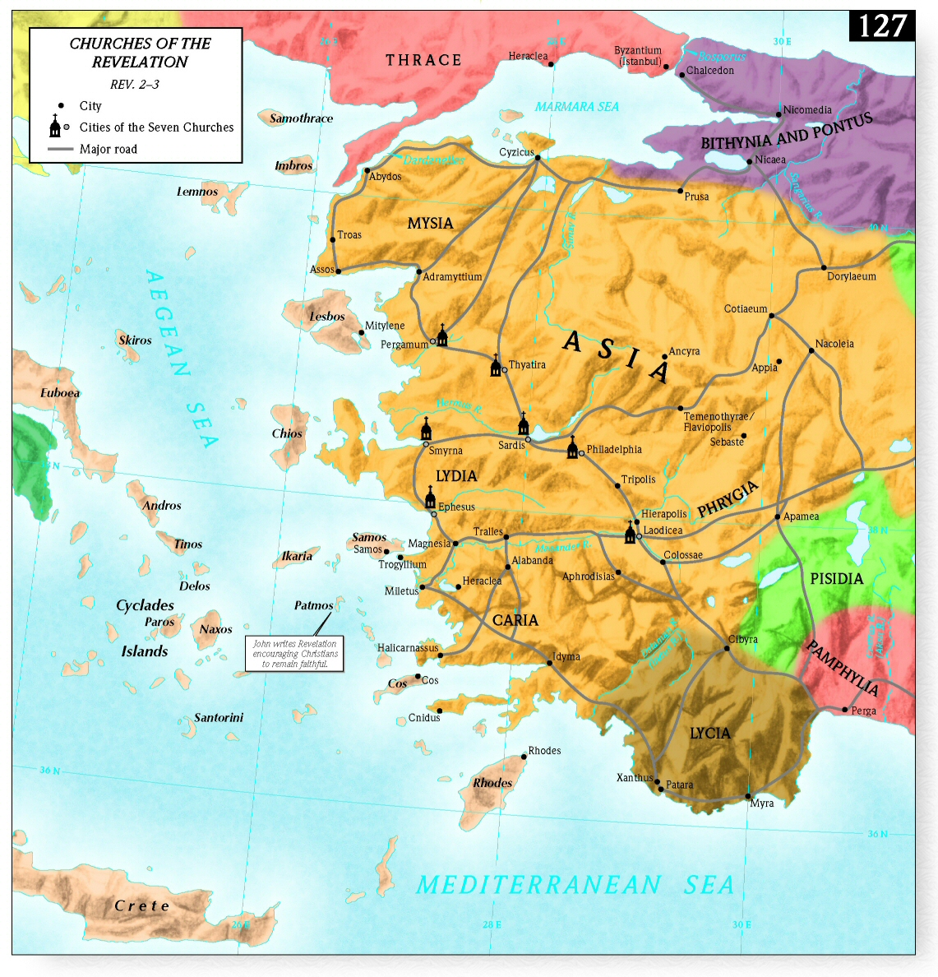
Address (v 12a)
- I’ve already discussed the possible options about this being a real guardian angel over the church or the minister of the church. Regardless, Jesus is still in the midst of the lampstands and He is still tending to His Church.
Christ’s Self-designation (v12b)
- Christ’s designation is now of Him holding a 2-edged sword.
- Christ’s self-designation here as a warrior shows that He is getting ready to bring a battle to His very church if they do not repent of their heresy.
- Christ is standing over His church ready to judge her.
Christ’s Commendation (vv13)
- Some scholars identify the altar of Zeus with “Satan’s throne,” but more likely Pergamum’s close connection with the imperial cult accounts for John’s use of the phrase.
- At one point, Pergamum was the capital of Asia for the Roman Empire so there were numerous temples dedicated to worshipping Caesar. In fact, Pergamum contained the oldest temple in Asia Minor devoted to emperor worship. Refusal to worship the emperor and say “Caesar is Lord” was equivalent to treason and punishable by death.
- So, the church at Pergamum is in the middle of enemy territory. Jesus says at the beginning of verse 13 that Satan’s throne is there and at the end of the verse Jesus says Satan dwells there.
- “Consequently, in such an atmosphere it would be more difficult for Christians to maintain a high profile about their faith without also running into conflict with those committed to the officially accepted pagan religions, behind all of which Satan stood as king.” –Greg Beale
- Despite that fact, however, they held fast to the name of Christ. Even when severe persecution broke out, they did not deny their faith in Christ. They clung to Christ as a drowning person clings to a life preserver.
- One person in particular is pointed out for his faithfulness, Antipas. We don’t know who this person was, but he’s forever enscripturated as someone who was faithful to Jesus even to the point of death. And the church is commended because even his death didn’t scare them into denying Christ.
Christ’s Condemnation (vv14-15)
- But the problem with the church at Pergamum is they have tolerated some false teaching which has led to sinful actions and they haven’t exercised church discipline.
- The teaching of Balaam goes back to Numbers 22-25. Balaam is somebody who started off faithful but later apostatized and caused the people of God to commit idolatry and all sorts of sexual immorality.
- And so this church that has been faithful previously is in danger of apostasy because there are people in the church who are creating stumbling blocks by eating food sacrificed to idols and also committing sexual immorality. Some in the church at Pergamum stand in continuity with the false teaching and deception of Balaam. “Just as Israel was influenced to fornicate both sexually and spiritually, the same was true of Christians in Pergamum.” –Greg Beale
- Not only that, but others in the Church hold to the teaching of the Nicolaitans who we saw 2 weeks ago had also tried to infiltrate Ephesus but Ephesus hated the works of the Nicolaitans. This was a heretical group who tried to promote compromise between the church and the world. It’s ok to participate in the pagan festivals or to eat food as an act of worship
- So the church at Pergamum faithfully resisted external persecution, but they failed to guard themselves internally and were starting to compromise with no exercise of church discipline whatsoever.
Christ’s Promise/Threat (v16)
- Repent and if you don’t I’m coming against you in battle with the sword of my mouth. Now this is interesting because Balaam was killed in battle (Josh 13:22) and Numbers 31:8 says he was killed “by the sword.” The same thing that befell Balaam will befall you, Church, who are doing the same things that Balaam caused Israel to do.
- Stop tolerating these 2 movements within your midst and get rid of them. Excommunicate them. Exercise the church discipline and authority that Christ has given to you.
Christ’s Exhortation (v17a)
- Again this message goes beyond Pergamum to all churches, even today. But only the Spirit can give us the ears to hear what the Spirit is saying.
Christ’s Promise (v17b)
- If the church can overcome its sin of tolerance and administer discipline to both groups, then Christ promises 2 things: “hidden manna” and “a white stone”
- Hidden manna – Christ will nourish the faithful with an unfailing supply of heavenly, spiritual food.
- Hebrews 9:3-4 – “Behind the second curtain was a second section called the Most Holy Place, ⁴ having the golden altar of incense and the ark of the covenant covered on all sides with gold, in which was a golden urn holding the manna, and Aaron’s staff that budded, and the tablets of the covenant.”
- John 6:35 – “Jesus said to them, “I am the bread of life; whoever comes to me shall not hunger…”
- “Israel should have relied on God’s heavenly food for their sustenance rather than partaking of idolatrous food, and the church will partake of heavenly manna if it does not compromise in the same way.” –Greg Beale
- White stone – Scholars have suggested a wide variety of meaning about this white stone:
  - The stones that the high priest wore in his breastplate, which were inscribed with the names of the tribes of Israel.
  - A reference to Greek games, in which the winner of an event was given a white stone with a special name on it.
  - In a judicial court, when a verdict was announced, the judge would take one of two stones, either black or white, and put it in a jar. Black = guilty; White = innocent
  - The white stone is a person’s ticket of admission to the feast of the Great King.
- Revelation 3:12 – “The one who conquers, I will make him a pillar in the temple of my God. Never shall he go out of it, and I will write on him the name of my God, and the name of the city of my God, the new Jerusalem, which comes down from my God out of heaven, and my own new name.”
- Revelation 14:1 – “Then I looked, and behold, on Mount Zion stood the Lamb, and with him 144,000 who had his name and his Father’s name written on their foreheads.”
- Revelation 22:3-4 – “No longer will there be anything accursed, but the throne of God and of the Lamb will be in it, and his servants will worship him. ⁴ They will see his face, and his name will be on their foreheads.”
- In the Old Testament, the high priest wore a golden plate on the front of his turban and the golden plate was inscribed with “Holy to Yahweh.”
- “Just as during the old dispensation the name of Yahweh was written on the forehead of the high priest to indicate that he was the specially consecrated servant of Yahweh; so believers – who are constantly called priests in the Apocalypse – shall have a new name written on their foreheads, namely, the name of Christ, His new name. Moreover, just as in the old dispensation only the high priest knew how to pronounce the name Yahweh, so in the new, only believers know the blessed meaning of the name of the Lord Jesus Christ. They – and they alone – know the meaning of fellowship with Him.” –William Hendricksen
Message for Us
- Pergamum also endured persecution like the church in Smyrna, however unlike the church in Ephesus, the church in Pergamum had not been as protective of sound doctrine and had allowed error and heresy to enter and remain within her midst. Again, sound doctrine is just as important to the Lord as loving Him with all your being and sound doctrine is just as important to the Lord as remaining a faithful witness to Christ in the midst of persecution. We can’t prioritize doctrine over love or faithfulness over doctrine. We all have to fight to maintain all 3 of these things – doctrine, love, and faithfulness.
- Pergamum was becoming a worldly church. Joel Beeke writes, “The letter to Smyrna reveals the church in the world, whereas the letter to Pergamum reveals the world in the church.” When you take stock of yourself, do you see yourself growing in godliness or worldliness? Are you more willing to compromise with the world than you are to devote yourself to God? As Joel Beeke puts it, “Are you living more for this world than the next?”
- If a church doesn’t practice church discipline faithfully and in accord with Scripture, God Himself will carry out His own discipline upon His Church.

